MATCH 3 STARTER V 1.1
DOCUMENT GUIDE

Game rules:
You must match 3 or more objects to remove them.
- Objects cannot go throught stone blocks.
- You cannot match object hidden by glass blocks.
- If you match objects near glass/stone block, it will remove that blocks.

- Project structure:
Our project have some folders like this:
- Animations: contain all animation file for items.
- GUI: contain all images and prefabs of game.
- Resources: contain sound files, prefabs, map data.
- Scenes: contain scenes.
- Scripts: All script files in here.
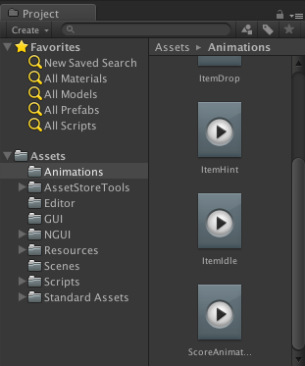

- Classes:
Script/Gameplay folder:
- Combine.cs: Entity to display one match 3.

- GamePlay.cs: class for game logic management.

- LevelData.cs : class to read map data and missions.

- Map.cs: We call our level is one map. Each map will be have many squares.

- Mission.cs: Entity to display one mission (score, block, ring, …)

- MissionManager.cs: Class to manage player’s scores.

Script/Objects folder
- Item.cs, ItemObject.cs : we call each candy/jewel/… is one item. And this class is use to manage them.

- Square.cs: each item will be put into one square on scene. This class will be used to manage the squares.

- SquareObject.cs: Square class will use to manage square’s actions like remove game objects, add game objects and SquareObject class will be used to manage physical game object’s params.

Script/MapEditor folder
- MapEditor.cs: Our project have 2 mode: play mode and edit mode. In EditMode, you can create game levels and save to text files. And MapEditor class will help you to control it.
Others
- SoundEffect.cs: This class use to manage sound in game.

- Hierachy structure:

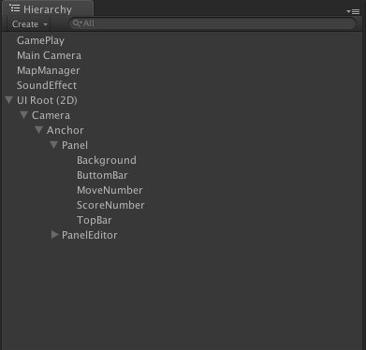

- GamePlay: we put component GamePlay.cs into this game object.
- MainCamera: we will not use it so you can inactive or remove it if you want.
- SounEffect: we put component SoundEffect.cs into this game object. Add Audio Listener and Audio Source components into this also.
- UIRoot(2D): open it and you can see inside there are 2 panels, one is Panel and one is PanelEditor. PanelEditor will be used in EditMode.
- MapManager: we add Map.cs class into this game object.
4. How to run in Edit Mode:
Our starter kit have 2 modes, one mode is play game, other mode is edit levels for game. To run in edit levels mode, please do like this:
1. Go to menu UNICORN/Create Map Editor . It will create one game object named MapEditor in Hierachy window.
2. Now, set Game tab to Free Aspect and click Play button.

Edit window:

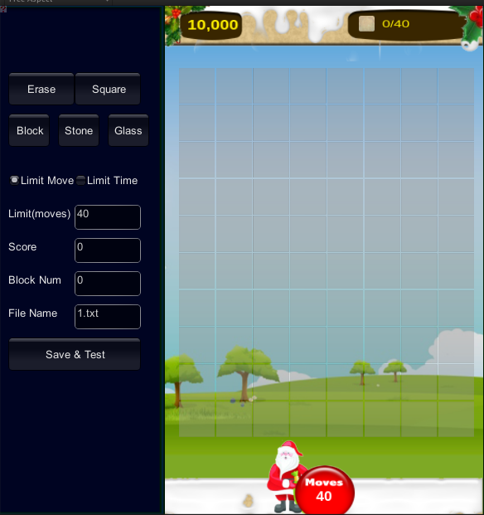

-Erase: Click this button and click squares in play scene, and it will remove squares.
-Square: Click this button and click block/stone block square, it will change that square to normal square.

-Block: Click this button and click squares in play scene, it will replace that square by one block.
-Stone: Click this button and click squares in play scene, it will replace that square by one stone block.
-Glass: Click this button and click squares in play scene, it will replace that square by one glass block.

- Limit move & Limit time: These check box to use to select game mode limit by movement or time.
- Limit(s) text box: Input the number of limit movement or time that you want.
- Score text box: Input the number of score that player must pass to win.
-Block num: This is read only, its value will depend on how many block/stone block on game scene.
- File name: File name of level you want to save in.
- Save and test: Whenever you finish edit, click this button it will save in to folder: Resources/Maps/

* Notice: Whenever you build game or want to run, please delete or inactive game object MapEditor in Hierarchy and set the screen size to mobile size.

- How to add more items:
You need do 2 steps:
- Go into Resource/Prefabs/Items to add more items prefab.
- Go into Item.cs class, add more type for ItemType.

- How to change item images:
You can change items’ image to anything you want by change candies.psd file and save to candies.png file or you can add items’ image into atlas by NGUI tool.

